Project Design Phase
Solution Architecture

Date | 28 September 2026
Team ID | 6ab221341
Project Name | Implement Client Script & UI Policy (Incident)
Maximum Marks | 4 Marks

Solution Architecture:
The solution architecture for Implementation of Client Scripts & UI Policies focuses on improving the behavior and usability of ServiceNow forms through client-side automation and configuration. The solution is designed to:
● Identify form requirements and determine where Client Scripts and UI Policies are required.
● Use Client Scripts to perform client-side validation, auto-populate fields, and dynamically respond to user actions.
● Use UI Policies to control field visibility, mandatory status, and read-only behavior based on specific conditions.
● Reduce manual data-entry errors and ensure that users provide the required information.
● Provide a simple, consistent, and user-friendly ServiceNow form experience.
● Define the required configurations, conditions, scripts, and testing steps for implementing the solution.

Example - Solution Architecture Diagram:
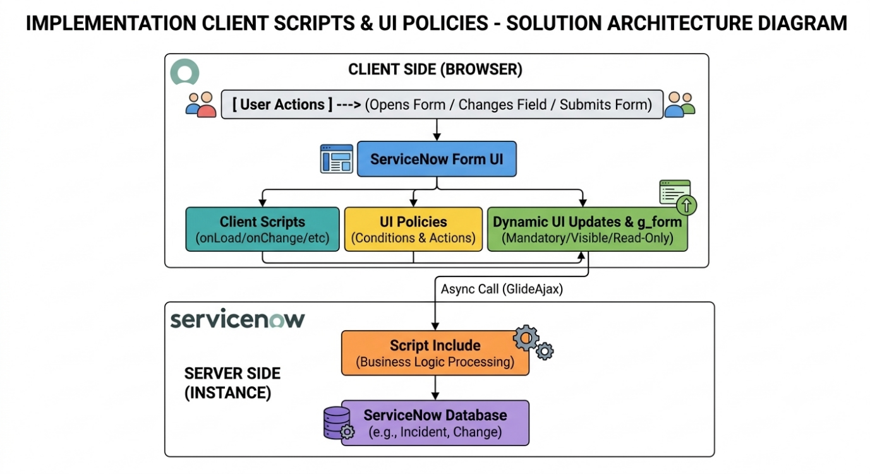
Figure 1: Architecture and data flow of the voice patient diary sample application

Reference:
- https://developer.servicenow.com/dev.do#!/learn/learning-plans/xanadu/servicenow_application_developer/app_store_learnv2_scripting_xanadu_client_scripts
- https://developer.servicenow.com/dev.do#!/learn/learning-plans/xanadu/servicenow_application_developer/app_store_learnv2_scripting_xanadu_ui_policies
- https://docs.servicenow.com/bundle/xanadu-application-development/page/script/client-scripts/concept/c_ClientScripts.html

